Installation guide

Step 1. Implement the database using “Database.txt” file in appendix 6.

Step 2. Load the Intellij project “Tier3Java”.

Step 3. Add the “gson-2.8.5.jar” and “MyDatabase.jar” as libraries.

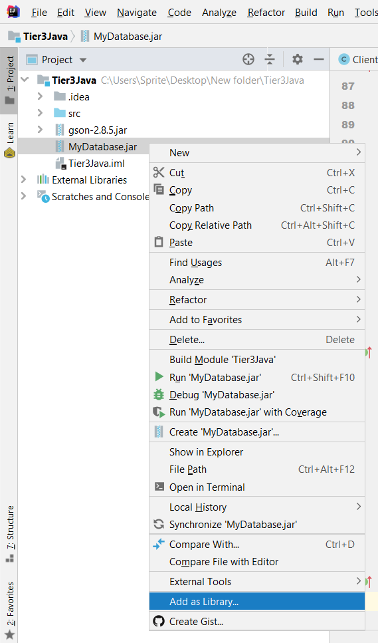

Step 5. Change the password In the class “Database” at line 46.

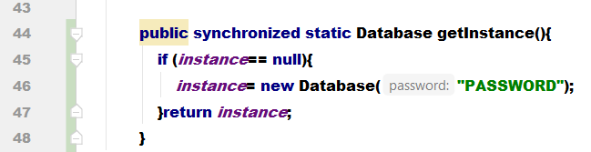

Step 5. Run the project.

Step 6. Load and run the Intellij project “Tier2Java” and add the “gson” jar as library.

Step 7. Run the project.

Step 8. Load the .Net “BlazorWebApp” project.

Step 9. Run the app trough ISS Express.

